**Digital Marketing Assignment -4**

|  |  |
| --- | --- |
| Student Name | Ramkumar A |
| Student Register Number | 953720106024 |
| College Name | AAA College of Engineering and Technology |
| Naan Mudhalvan ID | 3E6B37E1784D368932A45B438FA0D9C7 |

**Assignment:**

Create email newsletter design using Mailchimp or Canva tool

**Solution:**

Newsletter

Link: <https://www.canva.com/design/DAFtMnvaUUg/rOW0n1es48PAl_BQsgrlXw/edit?utm_content=DAFtMnvaUUg&utm_campaign=designshare&utm_medium=link2&utm_source=sharebutton>

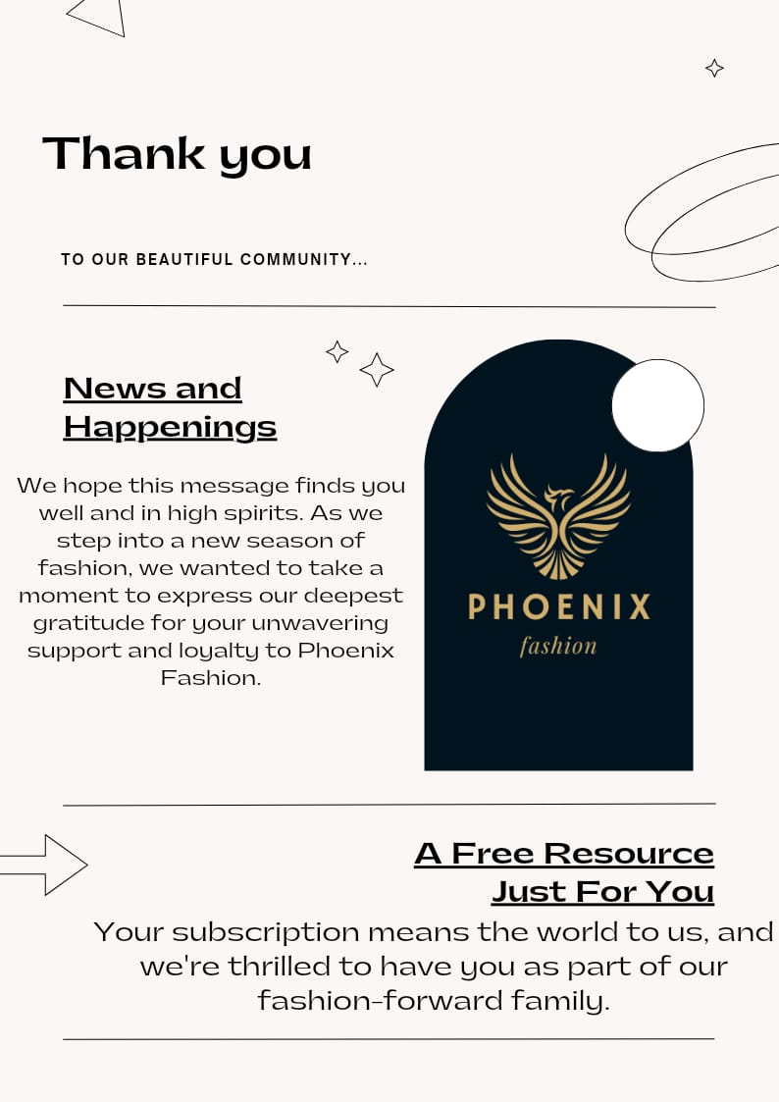s